Report CMF – Amandeep Dhaliwal 220188388

Introduction

The task was to complete a functioning website and we had a lot of options to choose from. I chose to create a website that allowed a user to make unit conversions; it will have weight, length and temperature conversions.

The programming language we have to use is HTML, CSS, and JavaScript. These are the common language used to develop a website with. CSS allows the website to personalise the presentation, layout, and format. JavaScript allows the website to be interactive.

Requirements

* Functioning web page
* Working Home button
* Each link to each unit conversion should load a new page.
* Conversion should be function when a number is inputted.

Project Management

I have broken down different elements of the website and which order I will complete them in.

Lists of Taks – The first and main task is that the user will be able to interact with the unit conversions and convert the values the user desires to do. They will be able to choose from which unit he wants to convert to and let him navigate with ease through the website.

The second task is to make the website interactive so there will be a home button on each page and on the home page there will be three-unit conversions and once clicked it will take you to a new page. On each page there will be a home button that allows easy access throughout the website.

List of Skill – For the first task I will need to learn how to allow the user to input the number and what conversion they wish to do. I have learnt basics of html in my labs, and I will use this knowledge as a base and use external resources to allow me to produce a functioning converter.

Task two I will need to dive into CSS and broaden my knowledge as I will have to place images and design each web page. I have learnt how to change background colour and text colour and that makes a big difference in a design of a webpage,

Design

I will be going for a minimalistic look, so the page will be user friendly and very easy for anybody to use. There will be a main page and the title will say Unit converter.

It will have a black background and white text. There will be 3 options Weight converter, length converter and temperature converter and each will have a picture so it’s clear to the user.

There will be a home button and that acts as a refresh and when you click on the different options the home button will also be there. This allows easy navigation between the different pages.

Each page will have their own conversion so you will submit your number that you want to convert, and the different measurements will display.

Design

The main page will be easy for the user to read. So, there will be a main clear title which will say Unit Converter in the middle at the top.

In the corner there will be a home button that a image will be of a standard home button. The text will be white, and the background will be black, a minimalistic design is very popular and is very user friendly.

Underneath will be a text that are displaying which converter and accompanied with it will be a image indicating the converter. Once clicked it will lead to a new page. On the new page it will have its own title so e.g., Weight converter with a home button in the top left corner. This allows easy navigation between the websites. Underneath that you will input your number and the conversion will take place. Each conversion webpage will have a light grey background and with a white title.

Implementation

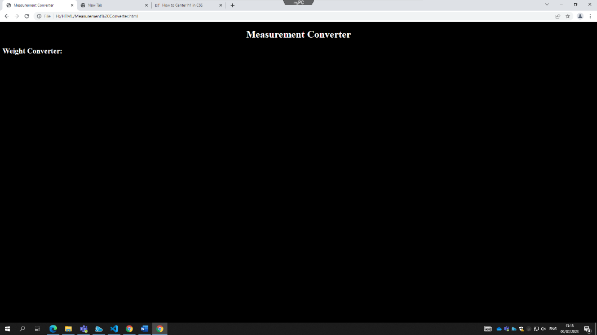09/02/2023

I started the code as you should with the tag <!DOCTYPE html> followed by <html>.

I made the title Measurement Converter as my website is a unit conversion web app.

I used a style to align h1 to the centre. I got the code from:

<https://linuxhint.com/center-h1-css/#:~:text=In%20the%20HTML%20file%2C%20set,add%20some%20text%20to%20it.&text=In%20the%20CSS%20file%2C%20we,heading%20h1%20to%20the%20center>.

I used a style to make the background black and made the text white.

I created heading called h2 to make a title.

Here is how the website looks like with this code

You can see the title is in the centre and one of the Converters is to the left.

<https://www.w3schools.com/html/tryit.asp?filename=tryhtml_images_trulli>

I have made a text and each text is a link that goes on to a new webpage. I have made 3 for each conversion.

This load a news page and it is accompanied by an image. The image also works as a link.

I have added these 3 images and as you can each will allow you to go on the other webpages.

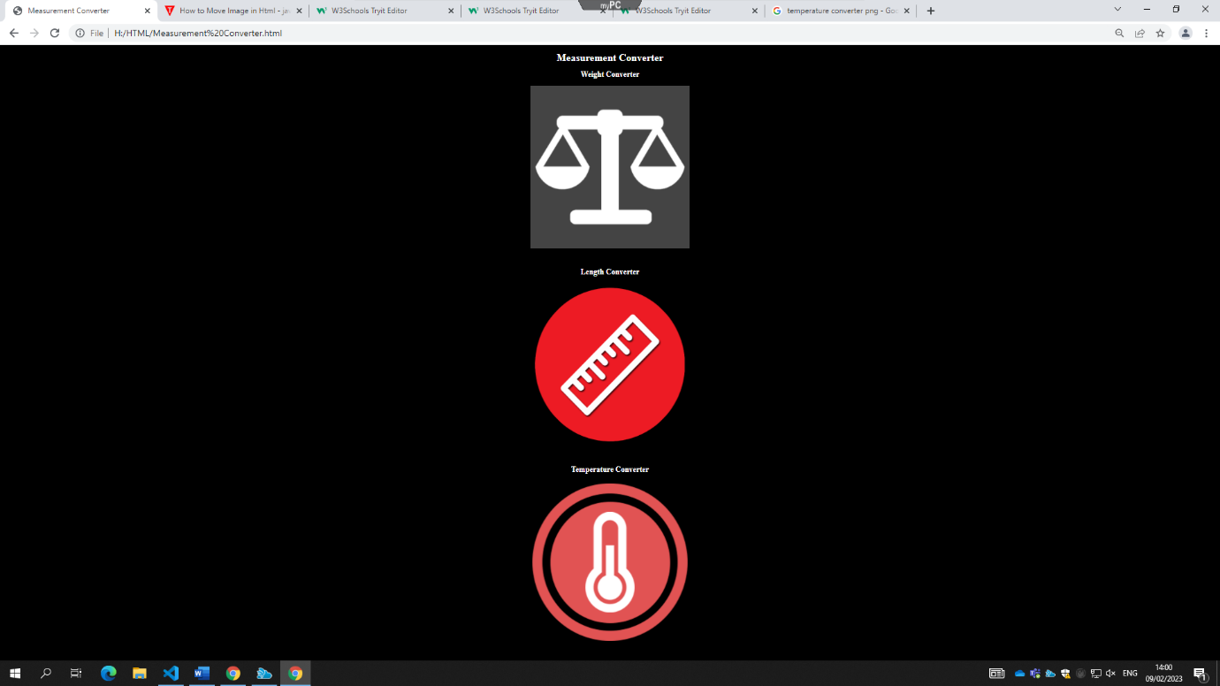

On line 17 and 18 you can see I have added an image and when you click on that image it will load the main converter webpage. If you’re on that page already it would simply just refresh the page.

This is the main page with the home button in the top left corner.

This is the first converter webpage (weight converter). So, I gave its title by using a style tag and made the title white, I made the background light slate Gray.

I have copied the home button code from the main webpage so when pressed it will return to that page.

This is what the website looks like with that code.

To allow the conversion to happen first I have to make a container div class and within that I created a row so it would be in a grid layout.

On line 28 I created a form tag this is used to collect information. This will allow you to input a number and it will store under kginput. Before you type your number, it will say Enter Kilograms…

Then I created an output for everything, so I sued a div and called the id output.

So, the outputs will be grams, pounds, and ounces and each is given their own id.

I have made a script this is the logic that allows the conversions to be made. So I used the input and make a function on there. So, I use the outputs and use the functions that will do calculations for the conversion.

I have used this code on each website and copied it to my other converter. All I changed was the inputs, outputs and each function.

I will place the screenshots underneath.

This is the end product for my website and I have kept the design the same as I want a basic website because I want it to be user friendly.

As you can see the unit conversions work and it shows which the conversions.

Conclusion

First, I had a mental image on how the website will look but as I coded somethings changed for example, I kept changing the background and images till it sat right with me. As I coded, I had help from my peers and tutor and I realised how easy it is to make simple mistakes. With this I always in a way proofread my code just in case. As I kept making mistakes, I started to go line over line as I was coding, and this helped a lot as I found errors before I even ran the code. In the project I was able to develop my skills in HTML, CSS and JavaScript and learnt the fundamentals and more to create a functioning website. Learning HTML will make learning other languages easier and more understandable. I believe HTML is a great way to start coding and it can get very complex so you can grow in the language as well.

References

<https://linuxhint.com/center-h1-css/#:~:text=In%20the%20HTML%20file%2C%20set,add%20some%20text%20to%20it.&text=In%20the%20CSS%20file%2C%20we,heading%20h1%20to%20the%20center>.

<https://vle.aston.ac.uk/ultra/courses/_38116_1/outline/edit/document/_3259345_1?courseId=_38116_1&view=content>

<https://www.w3schools.com/html/tryit.asp?filename=tryhtml_images_trulli>